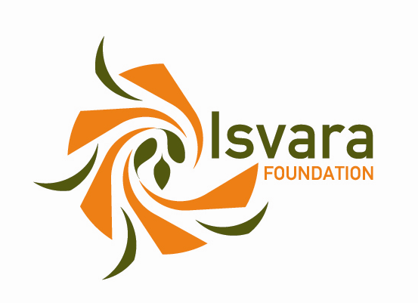

Isvara Foundation Project Grants Request Form
Deadline: January 10th, 2014

Part I: General Information
NOTE: Please use the space provided and do not exceed one page.

Name of Isvara advisory group recommending project: Corporate Europe Observatory

Date of application: January 10th, 2014

Name of organization requesting funds: Regards Citoyens

Contact information (address, telephone, fax, email):

Regards Citoyens

c/o Laurent GUERBY

10 chemin Tricou

31200 TOULOUSE

contact@regardscitoyens.org

06 81 88 02 98 or 06 83 82 34 66 or 06 07 06 09 07

Name and email address of person responsible for project:

Benjamin Ooghe Tabanou : contact@regardscitoyens.org

Tangui Morlier : contact@regardscitoyens.org

Name of project to be supported by Isvara Foundation: Digging lobby registries

Period of time grant will cover: April 2014 → April 2015

Total project budget (in EUR): 12 700

Total requested from Isvara Foundation (in EUR): 12 700

If the total project budget exceeds the amount requested from the Isvara Foundation, please list other sources of funds: -

Please add the bank account details needed for the transfer of the grant (in the case your application is approved). Please note that payments without a complete IBAN and BIC will not be processed.

Part II: Description of project
NOTE: Please use the space provided and do not exceed two pages.

1. Please provide a summary of the project in 100 words or less.

The European Parliament, the French National Assembly and other parliaments have created lobbyist registries pushed by civic organizations such as CEO, AlterEU, Transparency International or Regards Citoyens. Unfortunately, these registries are not transparent enough: they are not mandatory and the lobbyists are not forced to give the details of their activities. To push for more transparency, we would like to create a web application that would allow citizens to visualize the information contained into these registries, as well as try and fill missing data collaboratively.

2. Please give a brief overview of the background behind the project.

Regards Citoyens has been working on lobbying transparency since July 2010. We knew that the French lobbyist registry was not good enough — it is optional, and lacks financial and activity declaration. Therefore, we and Transparency International France decided to create a web application to reveal those shortcomings. Since no public information was available to show the gaps between the information published by the National Assembly and the reality, we decided to recreate a whole new dataset based on the list of hearings published at the end of MP's official reports. We built a crowd-sourcing application and, thanks to the help of thousands of citizens, we gathered enough data to publish a visualization application and a report revealing that at least 1500 companies and 700 NGOs were lobbying the French "députés" (MPs), whereas only 124 of them were registered on the official registry.

Since this seminal work, we've been advocating unrelentingly for more transparency of lobbying activities: we contribute occasionally to AlterEU's work, we have had meetings with the people in charge of this topic at the National Assembly, we have contributed to the reflexion about a new lobbyist registry, and we pushed for a stronger legislation on lobbying during the parliamentary debates on the political transparency bill discussed in 2013.

3. Please describe the overall political goal(s) of the proposed project. Be as specific as possible.

The goal of this project is to build and consolidate a link of trust between citizens and their institutions. We think that political transparency should not be a goal in itself, but a decisive tool to help citizens understanding how the democratic institutions work, and building trust towards them. We strongly believe that institutions will take advantage of this project as well. It will demonstrate them that defiance of citizens becomes unwarranted as soon as objective data are available: our past experience has taught us that people are more than willing to revisit their beliefs provided they are confident nothing is purposefully hidden.

The premises of this project is that, even though existing lobbyists registries are not perfect, they do contain some meaningful piece of information. We intend to fulfill our goal very concretely by extracting data from these registry and building a website to allow citizens exploring, understanding, and reusing them for their own purpose. Moreover, allowing anyone to report undeclared lobbies by filling unpublished information about their activities will help advocating for a better lobbyist registry at the European and national levels.

4. Please indicate the project’s relevance to the Isvara Foundation’s strategic priorities.

Bringing more transparency on lobbying activities will certainly reduce excessive corporate political influence.

Past experience makes us confident that this project can have a significant impact on lobbyist registries across Europe. For instance, our advocacy projects on French lobbying had national visibility: more than 3 000 people helped us create the data we needed to demonstrate how poor the National Assembly's registry was. Around 100 000 people visited the resulting website we published with Transparency International, and about 40 press articles reported on the project.

During the creation process of the new registry, Regards Citoyens had a significant influence on lobbying policies: lots of our recommendations were followed by Vice-President Christophe Sirugue to shape a new registry which now includes the details of lobbying activities of the participants. Further on during the transparency debates, about 20 members of the Parliament supported our amendment proposition to create a mandatory registry at the national level including both the executive and legislative branches.

5. Please describe the main activities and include a time-line, if available.

- Extraction of data out of the French Senate registry, National Assembly registry, European institutions one
;
- Creation of the database containing lobby information obtained from non similar registries
;
- Creation of visualizations describing declared lobbies
;
- Creation of a global interface giving a broader view of the lobbies at the French and the European level
;
- Creation of tools that would allow people to publish missing information about lobbyists activities
;
- Translation of the web interfaces
;
- Participation to European meetings with NGOs working on this topic
;
- Advocacy work to push at national level for a transparent and mandatory lobby register that would include the legislative and executive branches
;
- Participation to the advocacy work at the European level for a mandatory lobby register.

6. What political outcomes do you plan to achieve by the end of the project?

Thanks to the software and data we would develop during this project, we expect enough media and citizen attention to feed a momentum towards a debate on how lobbying should be regulated in France and Europe. We expect as well that these tools would help French and European citizens to understand how lobbies work and how they can push for their ideas at national and European level.

7. Is this a request for a renewal of Isvara Foundation support? If so, please indicate why funding of the project should be renewed.

No

8. Does your project/organisation have timely video footage that could be distributed to European media outlets? If so, please give us a short description of the content.

No

9. Please complete the attached “Itemized Budget.” The text in grey is for example only and should be deleted.

